

**Operating Systems (OS) Laboratory**



**DEPARTMENT OF COMPUTER SCIENCE & ENGINEERING**

Session: Aug 2020 – Dec 2020

**LABORATORY MANUAL**

|  |  |  |
| --- | --- | --- |
| Semester | : | FIFTH SEMESTER |
| Subject Code | : | UE18CS305 |
| Subject | : | OPERATING |
|  |  | SYSTEMS – LABORATORY |

Lab In charge : Prof. Venkatesh Prasad

**B Tech 5th Semester Aug - Dec 2020** **Department of Computer Science and Engineering** **Page 1**



**Operating Systems (OS) Laboratory**

**Learning Outcomes**

At the end of the course the student will be able to

1. Write programs to implement the basic functionality of an operating system and its components.
2. Write programs to implement the various scheduling algorithms and their performance tradeoffs.
3. Produce algorithmic solutions to process synchronization problems.
4. Write programs to implement memory, file and device management.

**B Tech 5th Semester Aug - Dec 2020** **Department of Computer Science and Engineering** **Page 2**





**Operating Systems (OS) Laboratory**

**WEEK 1 LAB**

**1.** **Execute and familiarize with Linux environment and commands**

* **Getting used to basic commands on Linux Operating System – Process creation, Process monitoring, Process states, Linux File system tree, Linux File system commands**

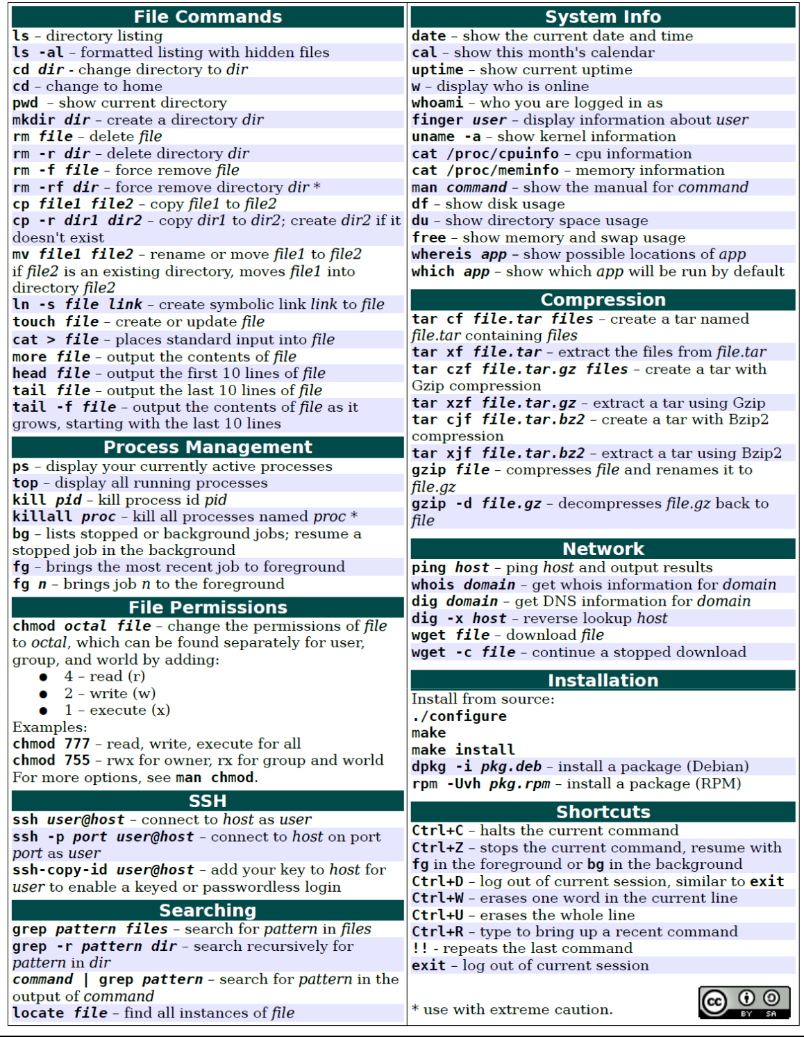

**B Tech 5th Semester Aug - Dec 2020** **Department of Computer Science and Engineering** **Page 3**

1. **Write a C program to display an array in reverse using index.**

**Create Makefile (ex: make.mk below) and other files as shown below: (Hint: Refer to Makefile tutorial sent before to create these files)**

**Client.c** – contains main function to collect input on array elements from the user and calls reverse_array function

**Server.c** – contains reverse_array function and prints the reversed array (use a separate function to print the reversed array)

**Header.h** – contains function prototypes

**make.mk** – contains targets and their dependencies

**Program Execution and Expected Output**

$make -f make.mk

$./a.out

ENTER SIZE OF AN ARRAY

4

ENTER ELEMENTS OF AN ARRAY

1

2

3

4

Input array is

1234

Reversed array is

4321

**Submission**

1. Basic LINUX commands (**ANY 5**) executed in the lab should be submitted in the following way:

Command: What does the command do?

Any two options (i.e flags or arguments) regarding the command

Outcome of the command

1. Main program and all sub programs (dependency files, header file and Makefile) should be submitted. Steps to execute make and output of the program should be submitted.
2. Answer the following questions (Brief answers only)

* **Why do we use Makefile?**
* **Is Makefile a shell script?**
* **What does “clean” do in Makefile?**
* **How does make learn about the last modified files to be complied?**
* **What does Cflags in Makefile mean?**
* **Why do we use -f option with make command?**